SYLLABUS CHECKER
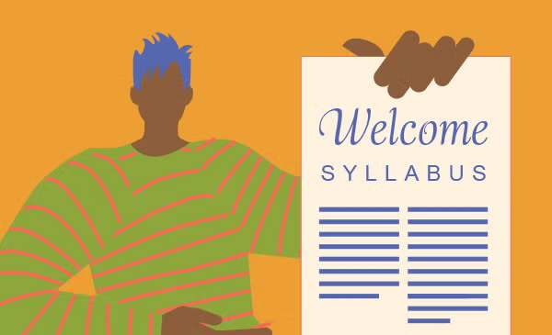
TEAM
Jack Demtshuk, Ishaq Halimi, Joscelin Montoya-Rojas, Rebecca Nanayakkara, Nicholas Taweel
CLIENT
Dr. Judith Ozment
Division Head of Science and Engineering
o96@psu.edu

Problem Statement
A syllabus is one of the most important documents a student receives, yet its quality and completeness can vary widely from course to course. Missing grading policies, unclear attendance expectations, or outdated accessibility statements can leave students confused and unprepared. Faculty at Penn State Abington are required to follow the detailed guidelines outlined in the Faculty Handbook, but checking every syllabus against these requirements can be time consuming and inconsistent. Current tools like Grammarly may help with grammar, but they cannot determine whether a syllabus contains all the elements that students and administrators expect.
The Syllabus Checker aims to solve this problem by providing an automated system that evaluates syllabi for both compliance and clarity. Our tool will go beyond grammar checks by identifying missing or outdated content, assessing readability, and generating actionable recommendations for improvement. In doing so, it supports instructors in creating documents that not only meet institutional policies but are also student friendly and accessible.
By automating this process, the project offers benefits across the board. Students will receive clearer, more reliable syllabi that help them plan and succeed in their classes. Faculty will save time and reduce the stress of manual reviews, while administrators can be confident that institutional standards are consistently met. In short, the Syllabus Checker will raise the overall quality of syllabi and improve the academic experience for everyone involved.

Related Work
When it comes to checking documents such as syllabi, there are already some tools out there that can handle parts of the job, but none of them really cover everything we are aiming for. For example, while Grammarly is great at catching grammar mistakes and spelling errors, it doesn’t know what specific content a syllabus is supposed to have. Grammarly won’t flag your syllabus if something important is missing, such as the grading policy, office hours or accessibility statements.
At our university, faculty have access to Appendix E of the Faculty Handbook, which lays out very detailed syllabus guidelines. These policies specify exactly what must be included, such as instructor contact information, office hours, attendance expectations, and more. In addition, according to the Faculty Handbook, copies of all syllabi have to be submitted to the professor’s division head within the first ten days of the semester. This means that reviewing these syllabi can be time consuming and requires a lot of responsibility for each syllabi to be manually checked for the required details.
This is where our project is different. The Syllabus Checker combines the strengths of existing tools while also focusing specifically on what makes a syllabus complete and student friendly. Our tool will not only fix grammar, it will look for required information, flag outdated content, and give recommendations on how to make the syllabus more readable. Ultimately, our tool is designed to support both professors and students, while also saving time for administrators who are responsible for reviewing syllabi.

Features
The “Syllabus Checker” tool we wish to create will scan syllabi for their quality and accuracy. The tool will check for certain required information from a user’s input syllabus, as well as see that it is grammatically correct and comprehensible. The tool would then output a list of sections that it found to be incorrect, a list of sections that it found to be insufficient, among other descriptive flags. All of this will be detectable by a machine learning model that we hope to create alongside this tool. Syllabi must be in a PDF format, so our tool can scan text directly from the file. If a syllabus were uploaded as an image file, like a .jpg or .png, it would require some form of computer vision and image processing.
Distinct information that the tool will check for include professor’s name, a grading policy, a course description, and required resources and hotlines. Some sections, such as the grading policy, will not be judged on its perceived fairness or quality as that is dependent on the professor and teaching style. Some courses or departments may have their own requirements. A case of this would be a lab course needing to outline lab safety. The naming and structure of each section will not require specific keywords. For example, a section titled “Grading Policy” is as valid as if it were named “How I Grade.” The program will rank syllabi on whether they pass or fail the check, by providing a grading scale where certain aspects that are required must be present or else they automatically fail, and aspects that are highly recommended are not present, or content is insufficient or overly complex, it will pass but with points deducted. When judging these sections, it will check that there is sufficient information. If a particular section is less detailed than it typically is, the tool will flag it. It will also check for the opposite, flagging where

parts are less simple than they should be. It will provide recommendations to the user on how to improve the syllabus based on the sections that fail to reach a passing grade. The tool will also check for syntax and grammar errors.
The tool is meant to be easy to use, with the expected users just being professors. Therefore, the interface will be very simple and only reliant on the inputted syllabus. We hope to make the output clear and concise, highlighting where the syllabus is lacking and recommending changes.

Use Case Diagram
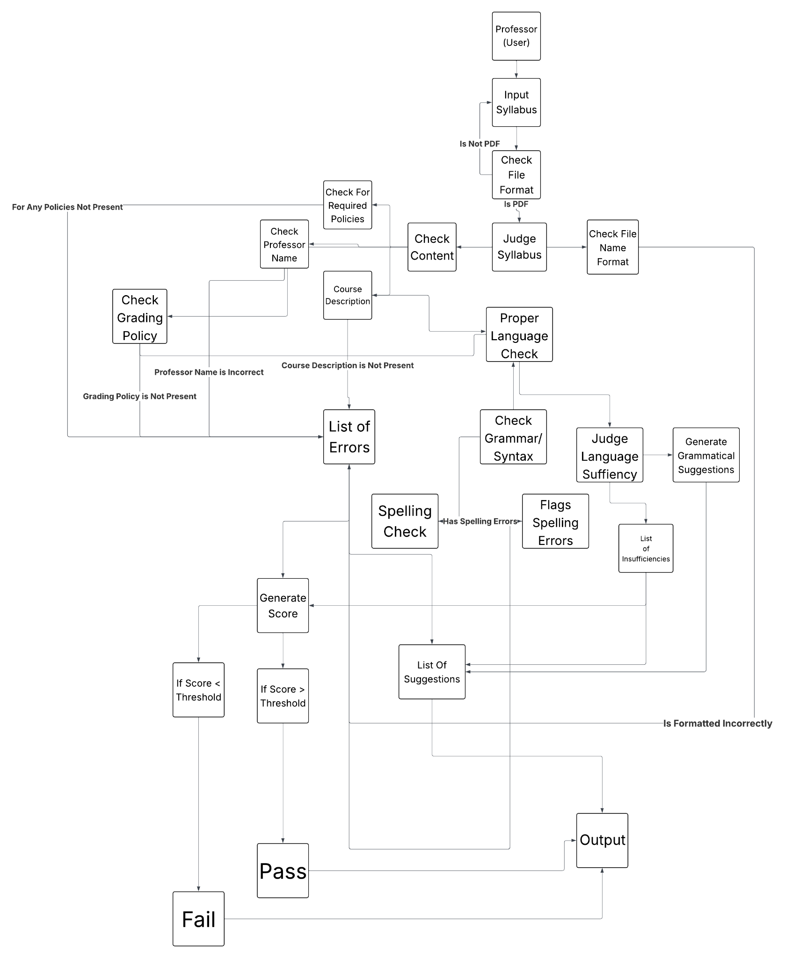
The program prompts the user to input a syllabus as a PDF file. It will first check to ensure that the file format is correct. If it is not, it will reject the input and ask for a new one. If it is, then the program will continue. The program then diverges into performing many analysis tasks on the input, such as required policies, name, spelling and grammar, and general readability. The program then produces a list of suggestions based on the results of these analyses, as well as generates a score to rate the input. The program will then output the input’s score, and whether they pass or fail the check. Some aspects of the input may cause automatic failure, such as missing required content. After receiving the score on the output, it will also provide the list of suggestions on how to improve the syllabus, regardless of score or pass/fail.

Required Tools and Technologies:
Some of the tools and technologies we will require for this project include Python 3.11. This would be best suited for our needs as python is a language that can provide libraries and has the flexibility needed for handling PDF files, analyzing text, and supporting any future machine learning we may implement.
For reading and processing syllabus, we will need tools such as PyPDF which would allow us to extract text directly from PDF files. And in cases where syllabus are word doc or images, it will first be converted into a PDF using tools like docx2pdf for documents and img2pdf for images, so that the program can process all files in the same way.
As a potential extension, we may also incorporate technologies such as machine learning frameworks using tools like scikit-learn or TensorFlow, which would allow the program to learn and grow at detecting missing or insufficient sections by learning from many syllabus examples.
Finally we will require a tool for professors to use our project and we will upload it using a simple interface such as Streamlit or FastAPI which will allow professors to upload their own syllabus and quickly receive a clear report of their results.

Work Plan
- Week of September 23: Acquire PSU Guidelines and Recommendations
We will start by reviewing all syllabus policies and guidelines from the Penn State Abington Faculty Handbook (2025-2026) to understand what is required in a syllabus, as well as look into and review what is recommended to be included in a syllabus by Penn State.
- Week of September 30: Review Sample Syllabi
We will then review sample syllabi to identify common features and formatting. This will help us build a flexible template that our program can use as reference. This will include training a machine learning model to identify aspects of syllabi that may be slightly different in presentation, but adequate in content, such as labels like “How I Grade” substituting the ‘official’ “Grading Policy”.
- Week of October 7, 14: Build the First Version of the Program
Using the template, we’ll create a program that can scan a syllabus and rate it based on its readability, whether it meets PSU Abington’s requirements, and overall user-friendliness.
October 16: Present project updates to the class.
- Week of October 21, 28: Make the Program Flexible
After the initial version, we’ll tweak our program so that it can handle different syllabus formats, variations, and unusual cases such as pictures or special fonts.
- Week of November 6, 11: Add Content Checks and Recommendations
Add the functionality where the program will flag missing our outdated sections and suggest improvements to make the syllabus more user-friendly for students.
November 6: Present project updates to the class.
- Ongoing: Regular Check-ins with Client
We plan on meeting with our client, Dr. Judy Ozment, every two to three weeks to ensure that we’re on the right track and that the project meets Dr. Ozment’s expectations.

Final Testing and Presentation
- Week of Dec 2, 4: Final Project Presentation
- Week of Dec 9, 11: Submit final project package, including:
  - Final Project Report (PDF)
  - PowerPoint Presentation Slides (PDF)
  - Evaluation Letter from Dr. Ozment
  - Source code or link to source code with instructions for running program

References
Penn State Abington Faculty Handbook 2025 - 2026
Syllabus Requirements
43-00 Syllabi | University Faculty Senate
CMPSC 487W: Software Engineering and Design Syllabus
Grammarly: Free AI Writing Assistance

Appendix
